5.11 |  | 服饰、鞋类 |  | 服饰箱包
Goon |  | 服饰 |  | 服饰箱包
uniqlo |  | 服饰 |  | 服饰箱包
COVEN GARDEN |  | 服饰 |  | 服饰箱包
Dazzle |  | 服饰 |  | 服饰箱包
ochirly |  | 服饰 |  | 服饰箱包
Five Plus |  | 服饰 |  | 服饰箱包
TRENDIANO |  | 服饰 |  | 服饰箱包
9FIFTY |  | 帽子 |  | 服饰箱包
acqua di parma |  | 服饰箱包、香水、化妆品 |  | 服饰箱包
arsenal |  | 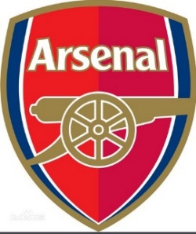PREMIER LEAGUE下俱乐部，服饰箱包，运动产品，礼品工艺品 |  | 服饰箱包
DYNEEMA |  | 运动产品、防护手套、绳 |  | 服饰箱包
manchester city |  | PREMIER LEAGUE下俱乐部，服饰箱包，运动产品，礼品工艺品 |  | 服饰箱包
l.f.c. |  | 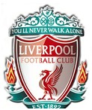  PREMIER LEAGUE下俱乐部，服饰箱包，运动产品，礼品工艺品 |  | 服饰箱包
180S |  | 耳罩 |  | 服饰箱包
SKIP HOP |  | 装婴儿用品用背包、手提包 |  | 服饰箱包
Chelsea FC |  |   PREMIER LEAGUE下俱乐部，服饰箱包，运动产品，礼品工艺品 |  | 服饰箱包
rock & republic |  | 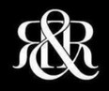  服饰箱包，鞋帽，珠宝 |  | 服饰箱包
Alex and Ani |  | 珠宝首饰 |  | 服饰箱包
Alhambra |  | 珠宝 |  | 服饰箱包
Allure Bridals |  | 服饰箱包 |  | 服饰箱包
Alpine Swiss |  | 靴子，钱包，卡包 |  | 服饰箱包
amway |  | 日用消费品 |  | 服饰箱包
Androextender |  | 文胸套装 |  | 服饰箱包
ARDELL |  | 假睫毛 |  | 服饰箱包
Atlanta Hawks |  | 篮球服 |  | 服饰箱包
AUTOMOBILI LAMBORGHINI |  | 服饰，玩具车,消费类电子产品 |  | 服饰箱包
angry birds |  | 服饰箱包，玩具，办公家居用品，食品烟酒，电子产品，美容洗护清洁用品，厨具家具 |  | 服饰箱包等
B BOGNER |  | 服装 |  | 服饰箱包
backjoy |  | 枕头，坐垫，座椅 |  | 服饰箱包
COPPER FIT |  | 主营服装（特别是护膝，护肘，腰封） |  | 服饰箱包
BAD BOY |  | 服饰 |  | 服饰箱包
BAREFOOT DREAMS |  | 服饰，毯子 |  | 服饰箱包
Batman |  | 性感角色类扮演服装 |  | 服饰箱包
Baume & Mercier |  | 钟表 |  | 服饰箱包
BEAUTYBLENDER |  | 化妆扑 |  | 服饰箱包
bebe |  | 服装 |  | 服饰箱包
Bell&Ross |  | 钟表 |  | 服饰箱包
BENCH |  | 服饰 |  | 服饰箱包
BENCH. |  | 服饰 |  | 服饰箱包
BERSHKA |  | 服饰箱包 |  | 服饰箱包
Bico Australia |  | 吊坠和饰物 |  | 服饰箱包
Blee Inara |  | 珠宝 |  | 服饰箱包
BLOCH |  | 鞋 |  | 服饰箱包
Bogner |  | 服装 |  | 服饰箱包
BOTOMASK |  | 化妆品 |  | 服饰箱包
Boucheron |  | 珠宝、腕表、香水 |  | 服饰箱包
Brixton |  | 服饰 |  | 服饰箱包
BTB 97 |  | 手链，手镯 |  | 服饰箱包
BUCKLE |  | 服饰 |  | 服饰箱包
BUFF |  | 头饰，围巾 |  | 服饰箱包
Burkini |  | 服饰 |  | 服饰箱包
Burqini |  | 服饰 |  | 服饰箱包
Case Logic |  | 箱包，数码产品保护套，塑封机 |  | 服饰箱包
CELEB Boutique |  | 服饰 |  | 服饰箱包
CELTIC |  | 足球服 |  | 服饰箱包
chanel |  | 全类目 |  | 服饰箱包
Charlotte Olympia |  | 鞋 |  | 服饰箱包
CHICAGO BULLS |  | 服饰 |  | 服饰箱包
ChicoBag |  | 箱包 |  | 服饰箱包
Christopher Kane |  | 服饰箱包 |  | 服饰箱包
CHUNK |  | 主营珠宝（包括手链、珠子等）。 |  | 服饰箱包
CLIMACOOL |  | 服装 |  | 服饰箱包
Cocksox |  | 内衣 |  | 服饰箱包
Crap |  | 眼镜 |  | 服饰箱包
DAINESE |  | 服饰，机车服为主 |  | 服饰箱包
Detroit Pistons |  | 帽子 |  | 服饰箱包
DEUTER |  | 箱包 |  | 服饰箱包
DFB |  | 足球球服 |  | 服饰箱包
DISOBEY |  | 帽子 |  | 服饰箱包
DOCKERS |  | 服饰 |  | 服饰箱包
dope |  | 帽子 |  | 服饰箱包
DR.MARTENS AIR CUSHION SOLE |  | 鞋 |  | 服饰箱包
dri-f.i.t. |  | 服装 |  | 服饰箱包
EAGLE EYES | 眼镜 |  | 服饰箱包
eastpak | 服饰箱包、手机壳、背包 |  | 服饰箱包
ECCO | 鞋 |  | 服饰箱包
Electric | 服饰、箱包、眼镜、手表 |  | 服饰箱包
Electric Visual | 眼镜 |  | 服饰箱包
Ermenegildo Zegna | 服饰 |  | 服饰箱包
ETRO | 箱包 |  | 服饰箱包
EVERLAST | 体育活动用品，服饰 |  | 服饰箱包
Faviana | 服饰箱包 |  | 服饰箱包
Find the Cure | 手链，手镯 |  | 服饰箱包
FIT FLOP | 主营产品：鞋类 |  | 服饰箱包
FRANCE LUXE | 配饰 |  | 服饰箱包
FreyWille | 珠宝 |  | 服饰箱包
Furla Candy Bag | 箱包 |  | 服饰箱包
Gentle Grip | 袜子 |  | 服饰箱包
GEORG JENSEN | 珠宝，钥匙链，餐具 |  | 服饰箱包
gionar | 箱包 |  | 服饰箱包
Girard-Perregaux | 钟表 |  | 服饰箱包
Grace Karin | 服饰 |  | 服饰箱包
G-SHOCK | 电子表 |  | 服饰箱包
H.STERN | 珠宝 |  | 服饰箱包
harmony ball | 珠宝首饰 |  | 服饰箱包
Harry Potter | 珠宝 |  | 服饰箱包
HAYABUSA | 服装，运动防护产品 |  | 服饰箱包
HAYLEY PAIGE | 婚纱礼服 |  | 服饰箱包
HEAT HOLDERS | 袜子 |  | 服饰箱包
HELL BUNNY | 服饰 |  | 服饰箱包
HELLS ANGELS | 水钻 |  | 服饰箱包
HICKIES | 鞋带 |  | 服饰箱包
Hilfiger Denim | 服饰 |  | 服饰箱包
HINANO TAHITI | 帽子 |  | 服饰箱包
HOG | 饰品 |  | 服饰箱包
HoodiePillow | 枕头 |  | 服饰箱包
Houston Rockets | 服饰 |  | 服饰箱包
HUF | 服饰 |  | 服饰箱包
HYDRA | 水晶泥 |  | 服饰箱包
ICON | 防护用品，如手套，服装，头盔等 |  | 服饰箱包
ILLUMINATOR | 手表 |  | 服饰箱包
Inditex | 服装，鞋 |  | 服饰箱包
Infantry | 手表 |  | 服饰箱包
Irish Setter | 鞋子 |  | 服饰箱包
IVY & ASTER | 婚纱礼服 |  | 服饰箱包
JACK SPADE | 箱包 |  | 服饰箱包
Jaeger-LeCoultre | 表 |  | 服饰箱包
JeanRichard | 钟表 |  | 服饰箱包
Jeffrey Campbell | 鞋子 |  | 服饰箱包
JANSPORT | 服饰箱包、手机壳 |  | 服饰箱包
Jibbitz | 鞋面饰花 |  | 服饰箱包
JIM HJELM | 婚纱礼服 |  | 服饰箱包
JJ'S HOUSE | 婚纱礼服 |  | 服饰箱包
John Cena | 运动帽 |  | 服饰箱包
JOHN DEERE | 帽子 |  | 服饰箱包
JOHN HARDY | 首饰 |  | 服饰箱包
Jovani | 服饰箱包 |  | 服饰箱包
Jump From Paper | 包 |  | 服饰箱包
Junk Food | 服装 |  | 服饰箱包
Justin Alexander | 婚纱礼服 |  | 服饰箱包
KANGOL | 帽子 |  | 服饰箱包
ka'oir | 服装 |  | 服饰箱包
Karen Walker | 太阳镜 |  | 服饰箱包
KENNTH JAY LANE | 珠宝 |  | 服饰箱包
KIABI | 服装 |  | 服饰箱包
Kimberly-Clark | 无纺布 |  | 服饰箱包
kimmidoll | 服装用标签 |  | 服饰箱包
kirei sui | 服装 |  | 服饰箱包
Kiwi | 鞋油 |  | 服饰箱包
KJP | 手链，手镯 |  | 服饰箱包
KJUS | 服装 |  | 服饰箱包
KM | 服装 |  | 服饰箱包
Knoxville | 太阳镜 |  | 服饰箱包
Lancel | 主营产品：箱包、服饰. |  | 服饰箱包
laperla | 服装 |  | 服饰箱包
LAZARO | 婚纱礼服 |  | 服饰箱包
LE PLIAGE | 化妆包 |  | 服饰箱包
lellikelly | 鞋子 |  | 服饰箱包
LEMTOSH | 眼镜镜架 |  | 服饰箱包
LINDY | 手袋 |  | 服饰箱包
LittleLife | 背包 |  | 服饰箱包
LIU.JO | 服饰 |  | 服饰箱包
Living Lockets | 珠宝首饰 |  | 服饰箱包
Louis Garneau | 运动服饰 |  | 服饰箱包
lululemon athletica | 服饰、佩饰、内衣裤 |  | 服饰箱包
Luminor | 钟表 |  | 服饰箱包
mcq | 服饰箱包、香水、化妆品 |  | 服饰箱包
M MECHANIX WEAR | 手套 |  | 服饰箱包
M MISS ME JEANS | 服装 |  | 服饰箱包
Marina Militare | 手表 |  | 服饰箱包
MATILDA JANE | 晚礼服 |  | 服饰箱包
Maui Jim | 太阳镜 |  | 服饰箱包
MAWI | 珠宝 |  | 服饰箱包
MECHANIX | 手套 |  | 服饰箱包
Mellow World | 斜挎包 |  | 服饰箱包
mendoza | 箱包 |  | 服饰箱包
mango | 服装 |  | 服饰箱包
marks&spencer | 服装 |  | 服饰箱包
MG Collection | 箱包 |  | 服饰箱包
Mi Moneda | 珠宝 |  | 服饰箱包
MICKEY MOUSE | 主营服饰箱包 |  | 服饰箱包
MILITARY ROYALE | 手表 |  | 服饰箱包
Minnetonka Moccasin | 靴子 |  | 服饰箱包
MINNIE MOUSE | 主营服饰 |  | 服饰箱包
MISS ME | 主营服装、箱包、化妆品 |  | 服饰箱包
MODALO | 手表及手表附件 |  | 服饰箱包
Mon Cheri | 服饰箱包 |  | 服饰箱包
Morphsuits | 紧身连衣裤 |  | 服饰箱包
Moscot | 太阳镜及镜架 |  | 服饰箱包
Mountain Equipment | 服装 |  | 服饰箱包
Mountain Hard Wear | 夹克，行李箱 |  | 服饰箱包
Moynat | 服饰箱包 |  | 服饰箱包
MULCO | 手表 |  | 服饰箱包
NBA | 主营服饰箱包运动产品。 |  | 服饰箱包
New Orleans Hornets | 运动帽 |  | 服饰箱包
new york knicks | 运动帽 |  | 服饰箱包
Night Moves | 服饰箱包 |  | 服饰箱包
NKY | 服装 |  | 服饰箱包
NOOSA | 佩饰，如：纽扣、戒指 |  | 服饰箱包
Nordic Grip | 鞋子 |  | 服饰箱包
OBEY | 帽子、服装、包 |  | 服饰箱包
ONE FOR ONE | 鞋子 |  | 服饰箱包
old navy | 服装 |  | 服饰箱包
O'neill | 服装，救生衣 |  | 服饰箱包
ONITSUKA TIGER | 鞋类 |  | 服饰箱包
ORTLIEB | 旅行包 |  | 服饰箱包
Ortlieb waterproof | 箱包 |  | 服饰箱包
OWK | 服装 |  | 服饰箱包
PACSAFE | 箱包 |  | 服饰箱包
PARAJUMPERS | 服装 |  | 服饰箱包
Peak Performance | 服装 |  | 服饰箱包
Philipp Plein | 服装 |  | 服饰箱包
Pomellato | 珠宝 |  | 服饰箱包
PRO TREK | 手表 |  | 服饰箱包
PROTECTION | 手表 |  | 服饰箱包
Qeelin | 珠宝 |  | 服饰箱包
Queen of Catwalk | 服装 |  | 服饰箱包
Rapala | 鱼饵，刀具,服饰，包 |  | 服饰箱包
RASTACLAT | 珠宝 |  | 服饰箱包
REBEL EIGHT | 帽子 |  | 服饰箱包
REBEL8 | 帽子 |  | 服饰箱包
Sherri Hill | 主营范围：裙子 |  | 服饰箱包
Sigma makeup | 化妆刷 |  | 服饰箱包
slim'n lift | 服饰、内衣裤 |  | 服饰箱包
Sparco | 赛车服饰、赛车配部件 |  | 服饰箱包
spy | 眼镜、背包、运动包 |  | 服饰箱包
spyoptic | 眼镜、背包 |  | 服饰箱包
STOKKE | 婴儿车 |  | 服饰箱包
Superdry | 主营产品：服饰、手表 |  | 服饰箱包
Tretorn | 鞋（含雨靴） |  | 服饰箱包
Tony Bowls | 服饰 |  | 服饰箱包
Triangl | 服装 |  | 服饰箱包
Trunki | 箱包 |  | 服饰箱包
TUMI | 箱包，电脑包，包装袋 |  | 服饰箱包
TYVEK | 防护服装、防护鞋及安全帽 |  | 服饰箱包
ulysse nardin | 手表 |  | 服饰箱包
U.S. POLO ASSN. | 服饰 |  | 服饰箱包
Under Armour | 服饰 |  | 服饰箱包
UNIWAX | 布料 |  | 服饰箱包
Vera Bradley | 箱包，毯子 |  | 服饰箱包
VERSUS | 太阳镜 |  | 服饰箱包
VITA FEDE | 珠宝 |  | 服饰箱包
VLISCO | 棉布 |  | 服饰箱包
VON ZIPPER | 眼镜 |  | 服饰箱包
VZ | 服饰 |  | 服饰箱包
Waiter Wallet | 钱包，便签本 |  | 服饰箱包
WOODIN | 布料 |  | 服饰箱包
Wayfarer | 眼镜 |  | 服饰箱包
World Gym | 健身服饰 |  | 服饰箱包
YSL | 箱包Y扣外观设计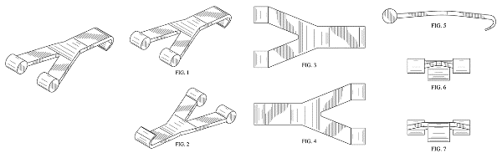 |  | 服饰箱包
yves saint laurent | 服饰箱包、化妆品、香水 |  | 服饰箱包
YURMAN | 珠宝 |  | 服饰箱包
ZIIIRO | 手表 |  | 服饰箱包
ONITSUKA TIGER | 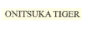 |  | 服饰箱包
NIALAYA | 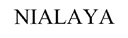 |  | 服饰箱包
PREMIER LEAGUE |  |  | 服饰箱包，运动产品，礼品工艺品
PANDORA | 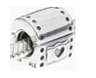 |  | 服饰箱包
7 For All Mankind |  |  | 服饰箱包
A&F |  |  | 服饰箱包
Arc'Teryx |  |  | 服饰箱包
Benetton | 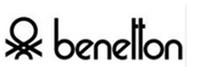 |  | 服饰箱包
chrome hearts |  |  | 服饰箱包
Ck |  |  | 服饰箱包
cristobal balenciaga | 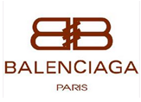 |  | 服饰箱包
Dior | 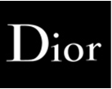 |  | 服饰箱包
donna karan new york |  |  | 服饰箱包
dsquared |  |  | 服饰箱包
emanuel ungaro | 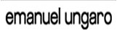 |  | 服饰箱包
Balenciaga | 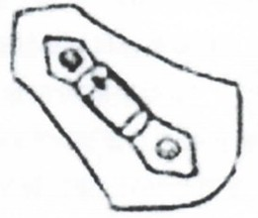 |  | 服饰箱包
F.C.B. |  |  | 服饰箱包
Fischer | 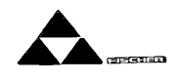 |  | 服饰箱包
Furla | 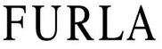 |  | 服饰箱包
Gore-Tex |  |  | 服饰箱包
G-Star |  |  | 服饰箱包
gymboree | 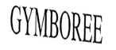 |  | 服饰箱包
Hollister Co. |  |  | 服饰箱包
ic! berlin |  |  | 服饰箱包
j.crew | 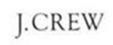 |  | 服饰箱包
Jack & Jones |  |  | 服饰箱包
Jack-Wolfskin |  |  | 服饰箱包
Juicy Couture | 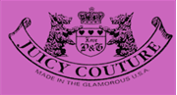 |  | 服饰箱包
JumpFromPaper |  |  | 服饰箱包
Kenzo |  |  | 服饰箱包
Levis | 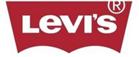 |  | 服饰箱包
long champ | 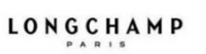 |  | 服饰箱包
loro piana | 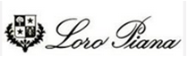 |  | 服饰箱包
LV | 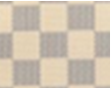 |  | 服饰箱包
Lyle Scott |  |  | 服饰箱包
M.A.C | 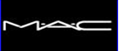 |  | 服饰箱包
Michael Jordan | 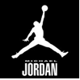 |  | 服饰箱包
MIKASA | 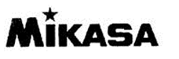 |  | 服饰箱包
mitchell&ness |  |  | 服饰箱包
moschino | 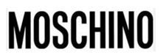 |  | 服饰箱包
MOULIN ROUGE | 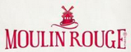 |  | 服饰箱包
No5 | 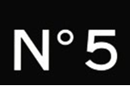 |  | 服饰箱包
Oscar De La Renta | 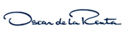 |  | 服饰箱包
PRADA | 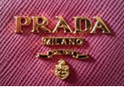 |  | 服饰箱包
Tracy Reese |  |  | 服饰箱包
Triangle Chalk | 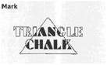 |  | 服饰箱包
True Religion | 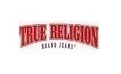 |  | 服饰箱包
TSE |  |  | 服饰箱包
Tudor | 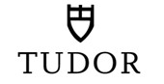 |  | 服饰箱包
Tuleh | 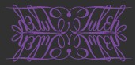 |  | 服饰箱包
Turbo Jam |  |  | 服饰箱包
Ubiq |  |  | 服饰箱包
U-Boat |  |  | 服饰箱包
UFC |  |  | 服饰箱包
Ugg |  |  | 服饰箱包
Ulysse Nardin |  |  | 服饰箱包
Umbro |  |  | 服饰箱包
Under Armour | 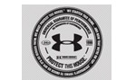 |  | 服饰箱包
Ungaro |  |  | 服饰箱包
United Colors of Benetton |  |  | 服饰箱包
Vacheron Constantin |  |  | 服饰箱包
Valentino Garavani | 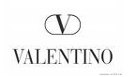 |  | 服饰箱包
Vans | 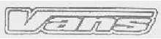 |  | 服饰箱包
Vena Cava | 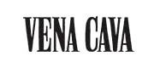 |  | 服饰箱包
Vera Bradley |  |  | 服饰箱包
Vera Wang |  |  | 服饰箱包
Vero Moda |  |  | 服饰箱包
Versace | 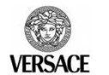 |  | 服饰箱包
Vibram | 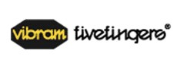 |  | 服饰箱包
Victoria's Secret | 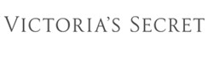 |  | 服饰箱包
Vince |  |  | 服饰箱包
Vivienne Westwood |  |  | 服饰箱包
Vlado | 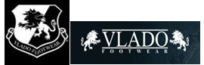 |  | 服饰箱包
Volcom |  |  | 服饰箱包
Volkl | 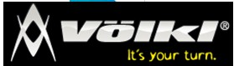 |  | 服饰箱包
Von Dutch | 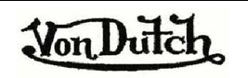 |  | 服饰箱包
Welder |  |  | 服饰箱包
Wilson |  | 服饰箱包
Wolford |  | 服饰箱包
Wrangler |  | 服饰箱包
Yigal Azroul |  | 服饰箱包
Yohji Yamamoto |  | 服饰箱包
Yonex |  | 服饰箱包
Yves Saint Laurent |  | 服饰箱包
Zac Posen |  | 服饰箱包
Zakumi (FIFA南非世界杯商标) |  | 服饰箱包
Zara |  | 服饰箱包
Zegna |  | 服饰箱包
Zenith |  | 服饰箱包

